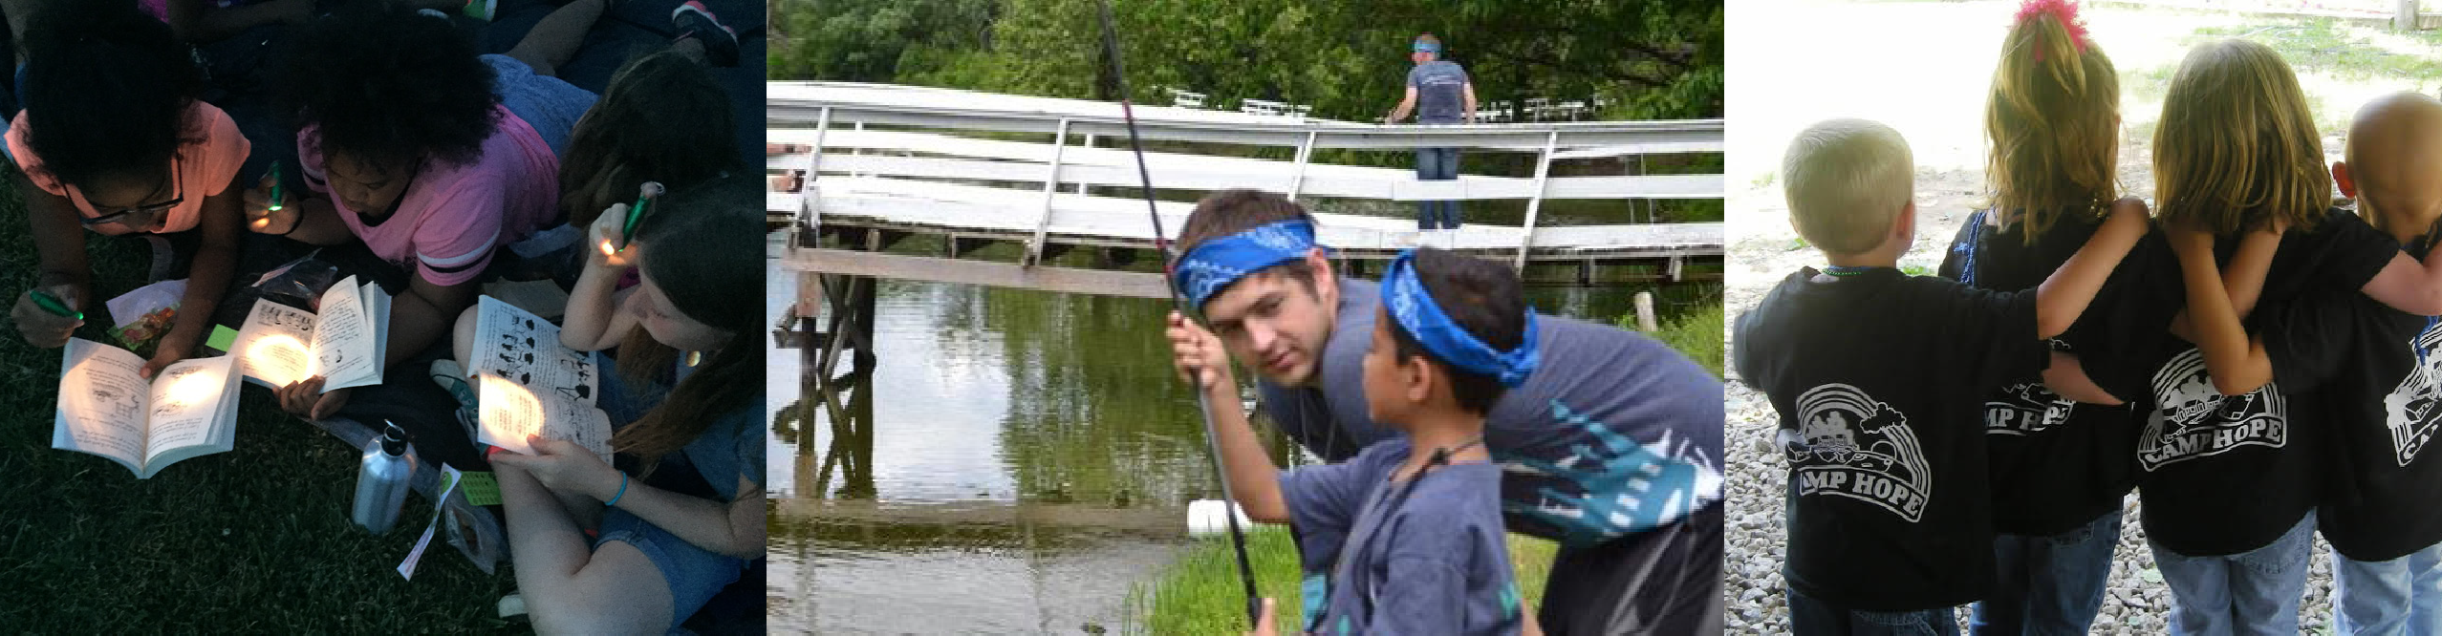

impact
GIVING YOUTH A SUMMER TO REMEMBER
CAMPs F O R K I D S

ANNUAL REPORT
2O18

OUR network
AILEYCAMP
By the KC Friends of Alvin Ailey, performing arts program, ages 11-14.
Kansas City, MO
CAMP CAROUSEL AND CAMP ERIN
For children suffering from a loss. Parkville, MO
CAMP CHIMER
For children with chronic kidney disease. Excelsior Springs, MO
CAMP ENCOURAGE
For children with autism spectrum disorders. Linwood, KS
CAMP HOPE
For children living with or have survived cancer. Great Bend, KS
CAMP MITIOG
For children born with Spina Bifida.
OUR MISSION
Camps For Kids works to assure that no Kansas City area child will be turned away from summer camp because of low income, or physical or developmental disabilities.

Excelsior Springs, MO
CAMP OASIS
For children with Crohn’s disease or ulcerative colitis. Potosi, MO
CAMP PLANET D
For children with Type 1 Diabetes. Linwood, KS
CAMP QUALITY
For children living with or who have survived cancer. Excelsior Springs, MO
CAMP SYSTOLE-CHD FAMILIES
For children living with congenital heart disease. Lawson, MO
CAMP WIN a sports day-camp
For girls ages 6-12. Kansas City, MO
HEARTLAND THERAPEUTIC
RIDING CAMP
21

CAMPS IN THE NETWORK
3,520

CHILDREN DISCOVERED THE WONDERS OF CAMP

For children with disabilities and also more typicallydeveloped peers.
Bucyrus, KS
SUPPORT FOR CAMPS FOR KIDS

KINGDOM KIDS CAMP
For neglected and abused children who are now in foster care.
Excelsior Springs, MO
JOSHUA CENTER CAMP
For kids diagnosed with autism spectrum disorder, Tourette’s Syndrome or OCD/ADHD.
Lee’s Summit, MO
MATTIE RHODES ART CAMP
For children with special emphasis on providing services to low-income and minority children. Kansas City, MO
MIDWEST CHILDREN’S BURN CAMP
For children with burn injuries. Rocky Mount, MO
ROYAL FAMILY KIDS CAMP
For kids in foster care. Linwood, KS
WHATSOEVER COMMUNITY CENTER
Provides underserved youth opportunities for academic enrichment and social development. Kansas City, MO

WILDWOOD OUTDOOR EDUCATION CENTER
Provides all Kansas City youth an experiential outdoor education program.
LaCygne, KS
WONDERLAND CAMP
For children and teenagers with developmental disabilities.
Rocky Mount, MO

More kids discovered the wonders of camp because of you.
$25,000 - $75,000
Hall Family Foundation Sarli Family Foundation
$10,000 - $24,999
W. J Brace Charitable Trust Oppenstein Brothers Foundation Ewing Marion Kauffman foundation Menorah Legacy Foundation
$5,000 - $9,999
Henry E. Wurst Family H&R Block Foundation Kansas Gas Service Sosland Foundation
R.A. Long Foundation
Vivian & Hymie J. Sosland Charitable Trust
$1,000 - $4,999
BlueScope Foundation The Massman Foundation Shook Hardy & Bacon LLP MoBank & BOK Financial
Copaken Family Foundation
Brad and Deon Pearson Family Fund Peter and Cappy Powell
Bill and Dianne Ryan
Peter Powell Family Foundation RTS Administrative Service, Inc Romanelli Dental
Hannah Orthodontics Tower Tavern
Mutual of Omaha Insurance Company Dunn Family Foundation
McCullough Family Foundation Gragg Advertising
$500 - $999
Mutual of Omaha Insurance Company Jonathan & Sarah Baum
Bret & Christy Wilson QuickTrip Corporation Keaton Construction Queen’s Price Chopper Andrews Family Foundation
TPP Certified Public Accountants, LLC Lowenstein Family
Supporting Foundation
Frank Newcomer III
$100 - $499
Jerry and Joy Kaplan Dean Kelley Michaela Voss Jamie Shada
Donald & Theresa Olson
Mary Olson & Arron Connet Audrey Gove
Kurt & Michelle Lamb Celtina Reinert
David and Renee Senter Julie Brickey
Gabe and Megan Egli Darryl and Jennifer Mattox Steven and Kenbra Deere Maria and Robert Flynn Micah Crabb
Christopher McQueen Don Broksieck
Kevin Kalish Betty Kessinger Kevin Obrien Juliana Webb Karen Read Jennifer Schreiner Tina Schaefer Margaret Steele Laurie Santee Brad Hanna
Bret and Christine Wilson Travis Braun
Jeffrey and Rebecca Schwartz Andrew Ryan

FINANCIALs*

income

Camp Designated donations** Unrestricted Gifts
Match Pool Gifts

$203,918

Total revenue 2018

expenses

Camp Designated donations** Match fund program
Fundraising

$176,937

Total expenses 2018

$167,928

*This information represents the unaudited figures for the year ending December 31, 2018. Current information is available at www.campsforkids.org or by emailing executivedirector@campsforkids.com
$456,846

$167,928
$85,000
& Administration

**As agents for our camps, camp-designated donations are not recognized as a Camps For Kids revenue or expense.
$444,710

$99,845

66% 54%

ZERO

NEEDED FINANCIAL ASSISTANCE
HAD A MEDICAL NEED

(SOME CHILDREN ARE COUNTED IN BOTH OF THESE CATEGORIES)
KIDS WERE TURNED AWAY FROM CAMP

Camp Designated Match Donors $1,000 and above
GRAM
Nancy Jane Woodworth & James Oldson Tracy and Sarah Johnson
David Pierson
Richards Collision Center Aaron North
Kirk Woodward/Karla Pullman Power LLC Randy Reed
Sporting Kansas City
Highlands Community of Christ Merrill Clark
Metro Snow Contractors, LLC Wardrip Landscaping, Inc.
Patricia & David Ross S.A.V.E.
Debra Heine Maryann Powell Mike McCoy Susan Decoursey
Adam Jones & Dr. Megan David Ford
Benjamin and Laura Huyett Lori Miller & Barry Reszel Champion Precast, Inc.
Christopher and Kelli Carlson Sara & Curt Humphrey
Champ Clark Service Coordination Caresa Doakes
Peter and Renee Kerckhoff Sunrise Optimist Club of Raymore Gina Hull
Karren Crouch
John and Sharon Hoffman Patricia Konopka
Central States Telecom, Inc.
Sunset Optimist Club of Blue Springs Harry Janke
Jonathan and Valerie Rexin Anne Johnson
Amel Corporation Tamla Edwards
Marcia Bailey & Stephen Bailey Sherry Gibbs
Hannibal Jaycees
Greater Kansas City Community Foundation

Charles Orth & Beth Rosemergey Rebecca Peck
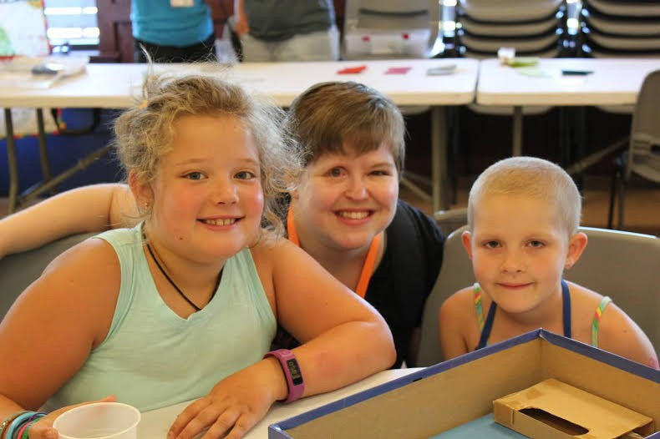Emerson Lisa Klein
Michael Weaver
Bradley and Shannon Warden The Signatry
Good Shepherd Catholic School Rod Lindemann
Judith Flynn Thomas Hendrix

Trinity Lutheran Church
Evening Optimist Club of Lee’s Summit Lafayette County Cancer Coalition
Allen and Sheila Laughlin Jerry Williams
Richard & Tina Metcalf Gateway Knights
St. Charles Jaycees Ronald and Janice Ohmes Leo Watson
Lockton Companies, LLC

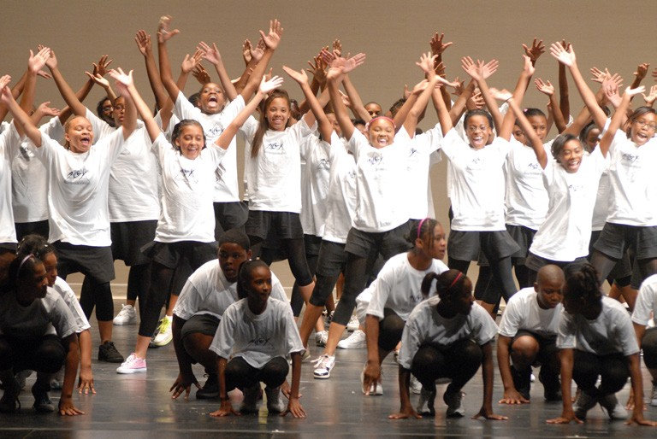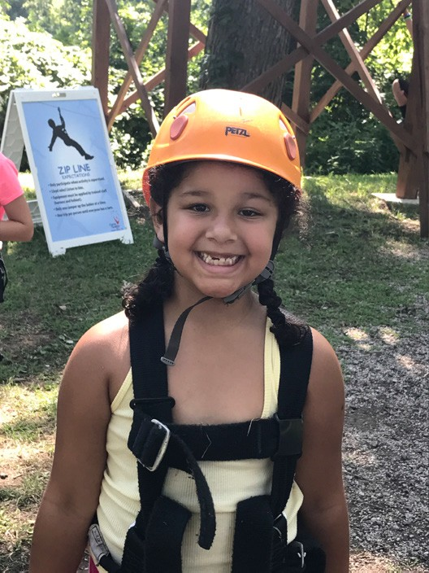

LEaderSHIP

2018 Board of
directors & Officers

Stacey Deere
President
Shook, Hardy & Bacon, LLP
Steven J. Streen First Vice President Attorney at Law PC
Darryl Mattox Second Vice President Gragg Advertising
Christopher McQueen
Treasurer
TPP Certified Public Accountants
Dianne Ryan
Secretary
Community volunteer
Members At Large
Spencer Dean
Spring Venture Group

Dana Mehrer
Community Volunteer

Susan Melton
Saint Luke’s Foundation

Brad I. Pearson
DeSimone Pearson, LC

Peter E. Powell
PHR Holdings, LLC

Celtina Reinert
Queen’s Price Chopper

David Senter, DVM, DACVD
Veterinary Allergy and Dermatology Clinic, LLC

Randy Spector
Kansas Gas Service

Burton Taylor
Proventus

Doug Wright, PhD.
University of Kansas Medical Center
HELP US CONTINUE TO GROW
  - Consider making a gift to send a child to camp

  - Tell 3 people about Camps For Kids
this year

  - Follow Camps For Kids on Facebook and Twitter

Look for news on upcoming events

campsforkids.org executivedirector@campsforkids.com facebook.com/campsforkids
Twitter handle : @Campsforkids

5913 Woodson, Suite 211
Mission, KS 66202
816.839.6494

